Immaculate Conception Parish

P O BOX 600 Tumut
Catholic Community
Collection amounts for January 2016 ~PARISH NEWS~
~ PARISH NEWS ~
~ A PASCHAL PRESCRIPTION ~

There is an old adage, now the motto for Outward Bound programs in the U.S. that reads, “If you can’t get out of something, get more deeply into it.” there is more than a little wisdom in that line, despite its rather glib sound. taken seriously, it is a paschal prescription, a challenge to die so that we might live.
Christ illustrated what that means in his prayer in Gethsemane. First he prayed that he might get out of it; “Father, let this cup pass from me.” Then, when he couldn’t get out of it, he got deeply into it. The result was the Resurrection. Many resurrections, for us, lie in imitating Christ in this. For example, today there are many people who are very unhappy with their churches but, for all kinds of reasons, can never leave those churches. If that is the case, then the prescription is clear; If you can’t get out of it, get more deeply into it. Enter your church more deeply, see and experience the tensions, pettiness, divisions, and angers of this particular community, the basic and universal struggle of all people to come together around one table, to have one heart.
The struggle for one community is, singularly, the most difficult and demanding of all human endeavors, Your local church offers you the laboratory to work at the project.

The struggle for one community is, singularly, the most difficult and demanding of all human endeavors.

An excerpt from Father Ron Rolbaiser. OMI

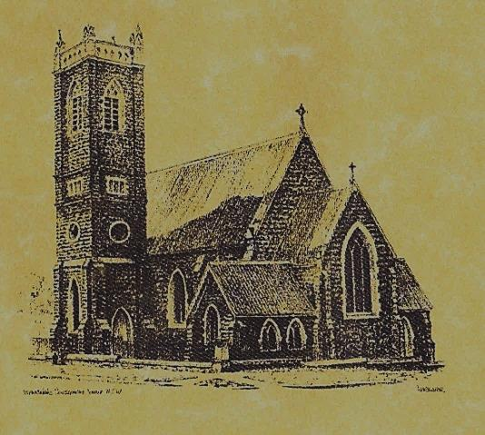

‘CLERGY’
- Fr. Sijo Jose (Parish Priest)
- Fr. George Ogah (Assistant Priest)

‘PARISH SECRETARY’
Anna Quinn
Phone: 02 69474599
Fax: 02 69474602
Email: tumut@cg.org.au
Web: www.cg.org.au/tumut
Office hours: Wednesday & Friday 9am -12noon
-------------------------------------------------------- ‘WEEKEND MASS TIMES’
Saturday Vigil: 6pm
Sunday: 10am (children’s liturgy) Talbingo Sunday: 8am
‘THIS WEEKS MASS TIMES’
Tuesday: 6pm in Chapel
Wednesday: 10am School Mass
Thursday & Friday: 8am in Chapel
Saturday: 9am (every fortnight – Thursday: 11am BUPA Liturgy Saturday: 9.40am BLAKENEY LODGE Liturgy)
‘ROSARY’
Saturday at 8.45am Exposition at 8.30am (1st Sat of month)
‘RECONCILIATION’
Saturday at 5.15pm
‘LITURGY MEETING’
Tuesday: 2pm in Chapel
‘PRAYER GROUP’
(Rosary & Divine Mercy)
Wednesday: 2pm in Chapel
‘CONTACTS’
Care Group: Anne Huebner 69473406

EASTER SUNDAY Year B
April 1st 2018

Entrance Antiphon
I have risen, and I am with you still, alleluia. You have laid your hand upon me, alleluia.
Too wonderful for me, this knowledge, alleluia, alleluia.
Responsorial Psalm
This is the day the Lord has made; let us rejoice and be glad.
Gospel Acclamation
Alleluia, alleluia! Christ has become our paschal sacrifice, let us feast with joy in the Lord. Alleluia!

Gospel Acclamation
-----------------------------------
Alleluia, alleluia! Tomorrow the wickedness of the earth will be destroyed; the Saviour of the world will be our king. Alleluia!

T THIS WEEK Saturday & Sunday 31st March & 1st April

Ministry | Easter Vigil 6pm | Easter Sunday 10am
Acolyte | Peter Malone | Dave Shedden
Reader | To be advised | To be advised
Commentator | To be advised | To be advised
Children’s Liturgy | ---------- | Caitlin Larter
Musicians | Patricia & Monica | Anna Quinn
Altar Servers | Jude Moreno & Hunter Styles | Jessica & Emily Kelly
Church Care  ________________________  LINEN Marie Ambrose | Group 5: Sandra, Maria & Margaret Dean
NEXT WEEK Saturday & Sunday 7th & 8th April
Ministry | Vigil 6pm |  | 10am
Acolyte | Anita Mason |  | Cath Purcell
Reader | Dobbie Family |  | Howard Young
Commentator | Dobbie Family |  | John Power
Children’s Liturgy | ---------- |  | Pat Spannagle
Musicians | Maureen Norman |  | Patricia & Monica
Altar Servers | New Servers |  | Annabelle Sturgess & Genevieve Mason-Elliott
Church Care | ---------------------------------------
Feast DayWishing all our wonderful dads a Happy In m
R O S T E R S
The family is where we are formed as people. Every family is a brick in the building of society. (Pope Francis)
FR.SIJO AND FR. GEORGE EXTEND THERE BLESSINGS AND GOOD WISHES TO ALL FOR A HAPPY AND HOLY EASTER
~PARISHNEWS~
Reminder to parishioners the weekly bulletin is available on our Web page www.cg.org.au/tumut – please remember to log on for weekly roster reminders if in doubt.
FEAST OF DIVINE MERCY St. Clement’s Monastery Galong will be celebrating this Feast on Sunday 8th April 2018. Please collect a flyer from notice board in church foyer.
SINCERE THANKS again to organisers and supporters of the St. Pat’s day luncheon who have kindly donated the proceeds ($481.50) to our parish. ~ ~ ~ ~ ~ ~ He is RISEN just as he said
MATTHEW 28 : 6

We pray for those who have gone before us marked with the sign of faith:
MASS HAS BEEN REQUESTED FOR:
Jim McInerney, Kath Stuckey, Iris Stuckey, Minnie Murphy, Alfred & Bridget Claffey, John Marzol, Joan & Pat Cronmy, Sean Gordon, Maureen Ashleigh,Kade Adams, Tom Sturt, Winifred Whitacker, Edward,Mary & Clem Malone, Pat Malone, Hickson & O’Sullivan families, Colleen Anderson, Reg & Mary Madigan, Matt Downing, Wilkinson & Downing families, Frank Stanfield, Peter Heffernan, Tim & Amy Twomey, Barbara Fuller, Tom & Merle Arentz, Harriet & Ruben Arentz, Kevin & Nola Arentz, Dulcie & Arthur Piper, Marie & Ray Cowan, Kevin Cowan, Kevin Hawthorne, Natalie Baker, Ian Barbour, Yvonne Harrison, Fr. Peter Quirk, Con & Ennis Twomey, Mons.John Twomey, Sr. M. Brenda Twomey, Sr. M. Canice O’Sullivan, Sr. M. Celine McCormack, Bert & Teresa Butler, Anne Lawrance, Joan & Bob Liddell, Mary & William Claffey, Ruby Harmer, Alan & Angela Guthrie, Hassel & Joy McGrath, Noel Cook, Hargreaves family, Family members & relatives of Tran family, Frederick & Mabel McInerney, Ken Elliott, Jock Roberts, Ralph Klaus, James Kelly, Harry & Muriel Nancarrow, Harry & Pat Nancarrow, Christine Welsh, Allison Brady, Scott Payne, Ben Roddy, Paul & Nick Young, Julie, Jack & Thelma Cobden, Stan Kenny, Russell & Peter Ritchie, Hector, Jean Kelly, Joan Malone, Ken & Brian Gee, Rudi & Filomena Comai, Celia Mullaly, Gus & Kath Clout, Ab & Mildred Shanahan, Ina Clout, Madelin Fenn, Chris Ballard, Maude Kelly, Frank, Eileen & Marie Malone, Pauline Shedden, John Hourigan, Tom & Dorothy French.

